# Dexamethasone as a Model of Stress

There are two types of stress, acute and chronic. Acute stress, in response to an immediate threat, is processed through the sympathetic nervous system to trigger a fight-or-flight response[1]. The acute stressor triggers the hypothalamic-pituitary-adrenal axis which releases cortisol/corticosterone in the cascade shown in *Figure 1*. If acute stress persists, this leads to chronic stress whereby cortisol/corticosterone levels remain elevated1 (Stephens & Wand, 2012).

Although the majority of research has focused on glucocorticoid exposure during midgestation, long after placental development is complete, the majority of research has failed to address lifestyle stressors that pregnant women may encounter like low socioeconomic status, institutional racism, shootings, and other traumatizing events. Institutional racism and the events of 9/11 in New York City caused reductions in birthweight (Collins *et al.*, 2004; Eskenazi *et al.*, 2007). As these prolonged stressful events are not yet explored in animal models, the mechanisms of action by which stress influences placental development are not understood. Furthermore, glucocorticoid exposure during lactation is scarcely studied.

Dexamethasone is used in our models since it is a potent synthetic glucocorticoid that replaces endogenous cortisol/corticosterone levels. When given at our dose of 1mg/kg/day, dexamethasone causes a state of elevated glucocorticoids and mimics a state of stress (De Souza *et al.*, 1973). My aim is to determine the exact mechanisms by which dexamethasone, a synthetic cortisol substrate used to mimic chronic stress, affects placentation prior to the development of the placenta and their effect on mammary gland function. Based on our results that will examine the mechanisms, our data can further be used to better understand the effect of stressors during different timepoints in early life.

## Figure 1: the HPA axis from “Know your brain: HPA axis”, 2014[2]

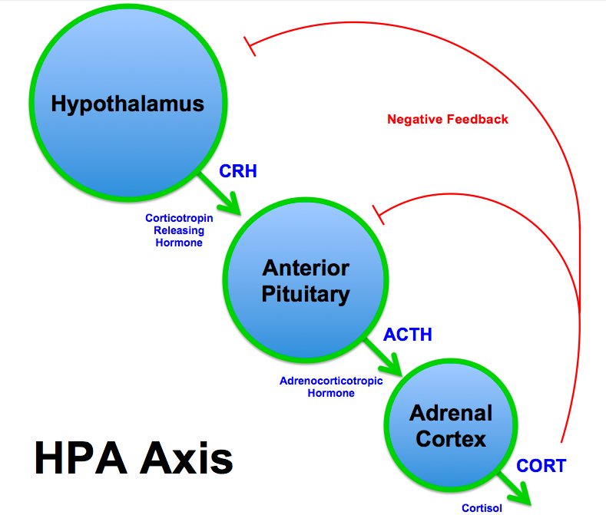

# mTORC1 Hyperactivation as a Model of Obesity

Placenta: As the majority of papers found increased placental mTORC1 activity in placentas from obese females (human and mouse studies cite), then this model further elucidates exact mechanisms of mTORC1 without the confounding variables in the mother (hormone changes, insulin resistance, increased maternal nutrient availability…). Strengths: better understand the role of mTORC1 as it has been implicated as the main driver of fetal growth in obesity. Limitations: does not replicate maternal obesity since we do not alter maternal health (hormones, fat mass, insulin sensitivity.)

Adipocytes?? For aTSC mammary glands

# Strengths and Limitations of Using Murine Models

## Mice vs Humans

## Mice vs Cells

Collins JW, David RJ, Handler A, Wall S, Andes S & Andes S (2004). Very low birthweight in African American infants: the role of maternal exposure to interpersonal racial discrimination. *Am J Public Health* **94,** 2132–2138.

Eskenazi B, Marks AR, Catalano R, Bruckner T & Toniolo PG (2007). Low birthweight in New York city and upstate New York following the events of September 11th. *Hum Reprod* **22,** 3013–3020.

De Souza SW, F Adlard BP & Souza D (1973). *Growth of suckling rats after treatment with dexamethasone or cortisol Implications for steroid therapy in human infants*. Available at: https://www.ncbi.nlm.nih.gov/pmc/articles/PMC1648459/pdf/archdisch00863-0029.pdf [Accessed August 18, 2019].

Stephens MAC & Wand G (2012). Stress and the HPA axis: role of glucocorticoids in alcohol dependence. *Alcohol Res* **34,** 468–483.

1. Understanding the stress response, Harvard Health Publishing, HHARVARD MEDICAL SCHOOL. Retrieved from <https://www.health.harvard.edu/staying-healthy/understanding-the-stress-response>
2. Know your brain: HPA axis, NEUROSCIENTIFICALLY CHALLENGED,Published June 04,2014. Retrieved from: <https://www.neuroscientificallychallenged.com/blog/2014/5/31/what-is-the-hpa-axis>